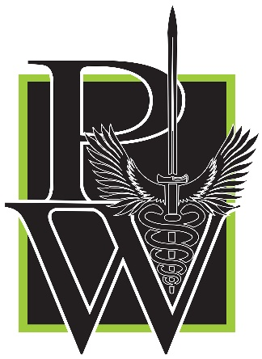
Peaceful Warrior Training Group

COURSE Name:

School Safety and Violent Event Incident Management (SSAVEIM)

COURSE Description:
(414) 573-9588
PWTRAININGGROUP.COM
pwtraininggroup@gmail.com

The interdisciplinary School Safety and Violent Event Incident Management (SSAVEIM) course incorporates all aspects of Active Threat events. Utilizing an enhanced tabletop format, this course is designed to cover all stages from the initial law enforcement response to reunifying students with their loved ones. By combining “best practice” elements of a validated scene management model (Active Shooter Incident Management from C3 Pathways) with the premier, nationally-recognized reunification system (the Standard Reunification Protocol from I Love You Guys Foundation), participants gain the critical skills required to tackle the "wave of chaos” that invariably occurs during the initial response to these complex emergencies. This course helps fulfill the planning, training, and drill requirements for schools and is guaranteed to enhance your organization’s existing safety/crisis plans.

SSAVEIM Instructor Bios

Capt. Michael Bolender
PW Training Group - Founder / Lead Instructor
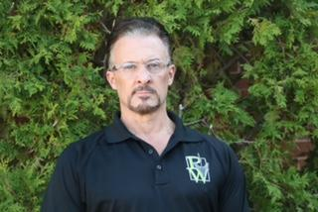
Mike served on the Oak Creek Police Department for 32 years. He retired as an Operations Captain overseeing the Patrol Division and the Communication Center. Mike also served as a Patrol Sergeant, and Lieutenant. He was the use-of-force trainer for 31 years and holds 26 different use-of-force instructor certifications. Mike has responded to two active shooters while working in Oak Creek. The first was in 2004 at Comfort Suites as one of Oak Creek’s SWAT Team Leaders and the second at the Sikh Temple in 2012 in which Mike was the incident commander. Mike spent 15 years on Oak Creek’s Emergency Response Unit (SWAT Team), 10 as a SWAT Team Leader. Mike started the Peaceful Warrior Training Group in 2013 after the Sikh Temple massacre, with a simple goal: never again. Our families and communities need our best efforts to ensure that we never again endure these tragedies.

Lisa Reid

PW Training Group - School Deployment Team Director / Instructor
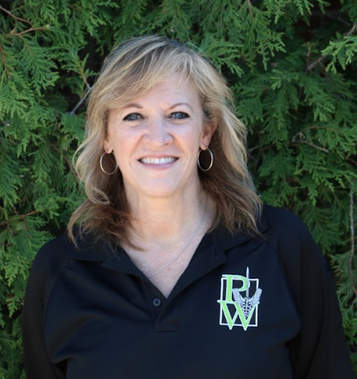
Lisa has been a School Psychologist in the Oak Creek-Franklin Jt. School District (OCFSD) since 1994 and the District Safety Coordinator since 2020. She was a co-founding member of the OCFSD’s District Safety Team and District Threat Assessment Team. Lisa was instrumental in developing the district's comprehensive Threat Assessment Guideline and Student Safety Lessons that are used for all grade levels. She is a certified instructor for the Crisis Prevention Institute (CPI), teaching Nonviolent Crisis Intervention and Verbal De-escalation techniques to school personnel. Lisa is also a member of the Critical Incident Response Team (CIRT) for the state, trained by Wisconsin's DOJ - Office of School Safety.

Jason Kelley
PW Training Group - Active Threat Instructor

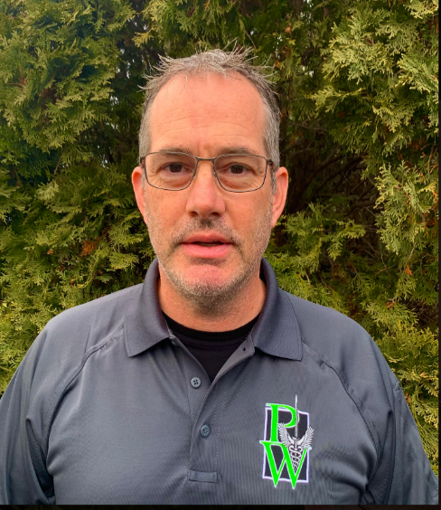
Jason retired in 2022 after 26 years at the Beloit (WI) Police Department. He was assigned to and held positions from Operator to Commander on the Tactical Operations Unit (SWAT Team) for 25 years. Jason was the primary firearms and tactics instructor for the department and Tactical Operations Unit. Jason has been involved in the Active Shooter response arena for over 20 years. He instructs nationwide for Advanced Law Enforcement Rapid Response Training (ALERRT) and C3 Pathways in Active Shooter response and incident management. In 2015, Jason co-founded the Trauma Preparedness Center at Mercy Health in Janesville, WI. He instructs Tactical Emergency Medical Support (TEMS), Civilian Response to Active Shooter Events (CRASE), Mass Casualty Trauma Care (MCTC), Rescue Task Force (RTF), Workplace Casualty Care (WPCC), Classroom Casualty Care (CCC), Sportsman Casualty Care (SPCC), and Therapeutic Alternatives in Crisis Training (TACT). He was a co-founding member of the Wisconsin Active Threat Integrated Response Conference (ATIRC). Jason also co-authored an article titled “Contained Threat Escort Tactics”, which inserted Fire/EMS into an Active Shooter Event (ASE) under the protection of law enforcement personnel. It was published in The Tactical Edge in 2001, a National Tactical Officer’s Association quarterly magazine.

Benjamin Kessel

PW Training Group - Director of Medical Training / Instructor
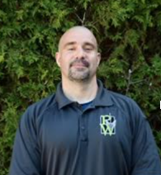
Ben has 22 years of experience as a Paramedic and Physician Assistant in prehospital EMS and Emergency Medicine, and 10 years as the lead SWAT medic. He is the Associate EMS Medical Director overseeing operations and training of multiple Fire departments and Law Enforcement agencies. Ben is a regional educator for multiple specialized tactical medicine certification courses, including military Tactical Combat Casualty Care (TCCC), civilian EMS Tactical Emergency Casualty Care (TECC), Tactical Emergency Casualty Care for Law Enforcement (TECC-LEO), and Bleeding Control for lay providers (B-Con). He has a passion for empowering “ordinary” people to successfully manage the extraordinary challenges of emergency response

Jack Rehn

PW Training Group - Emergency Medical Services Senior Instructor
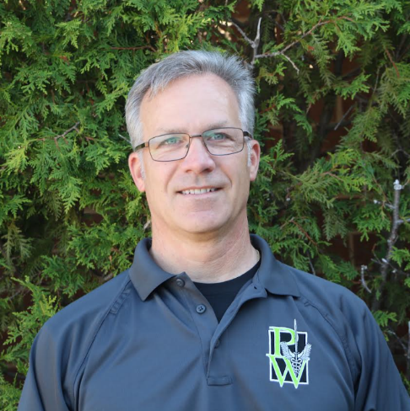
Jack is a retired 25-year veteran Fire Lieutenant Paramedic from the City of Oak Creek (WI). He has been a paramedic and active SWAT Medic for over 10 years. Jack is a founding member of the Oak Creek (WI) Fire and Police Department Tactical Emergency Medical Support Unit (TEMS), the first TEMS Unit to be credentialed by the State of Wisconsin. He instructs police recruits in First Care / Buddy Care through Milwaukee Area Technical College police academy.

